COINS-Eur-Greek-Ar Obol-3rd c **BCE**

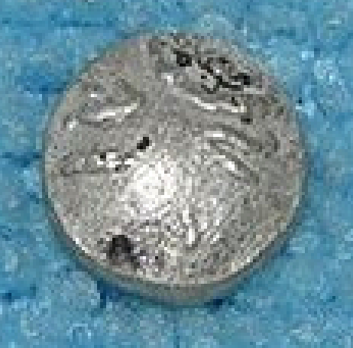

Eur-Greek-Ar Obol-3rd c **BCE**

**Case no.: Coins-Eur-Greek**

**Accession Number:**

**Formal Label:** Eur-Greek-Ar Obol-3rd c **BCE**

**Display Description:**

**LC Classification:**

**Date or Time Horizon:** 3rd c **BCE**

**Geographical Area:**

**Map:**

**GPS coordinates:**

**Cultural Affiliation:**

**Media:** silver

**Dimensions:** Dia 8mm

**Weight: 0.6g**

**Condition: very fine**

**Provenance:**

**Discussion:**

**References:**